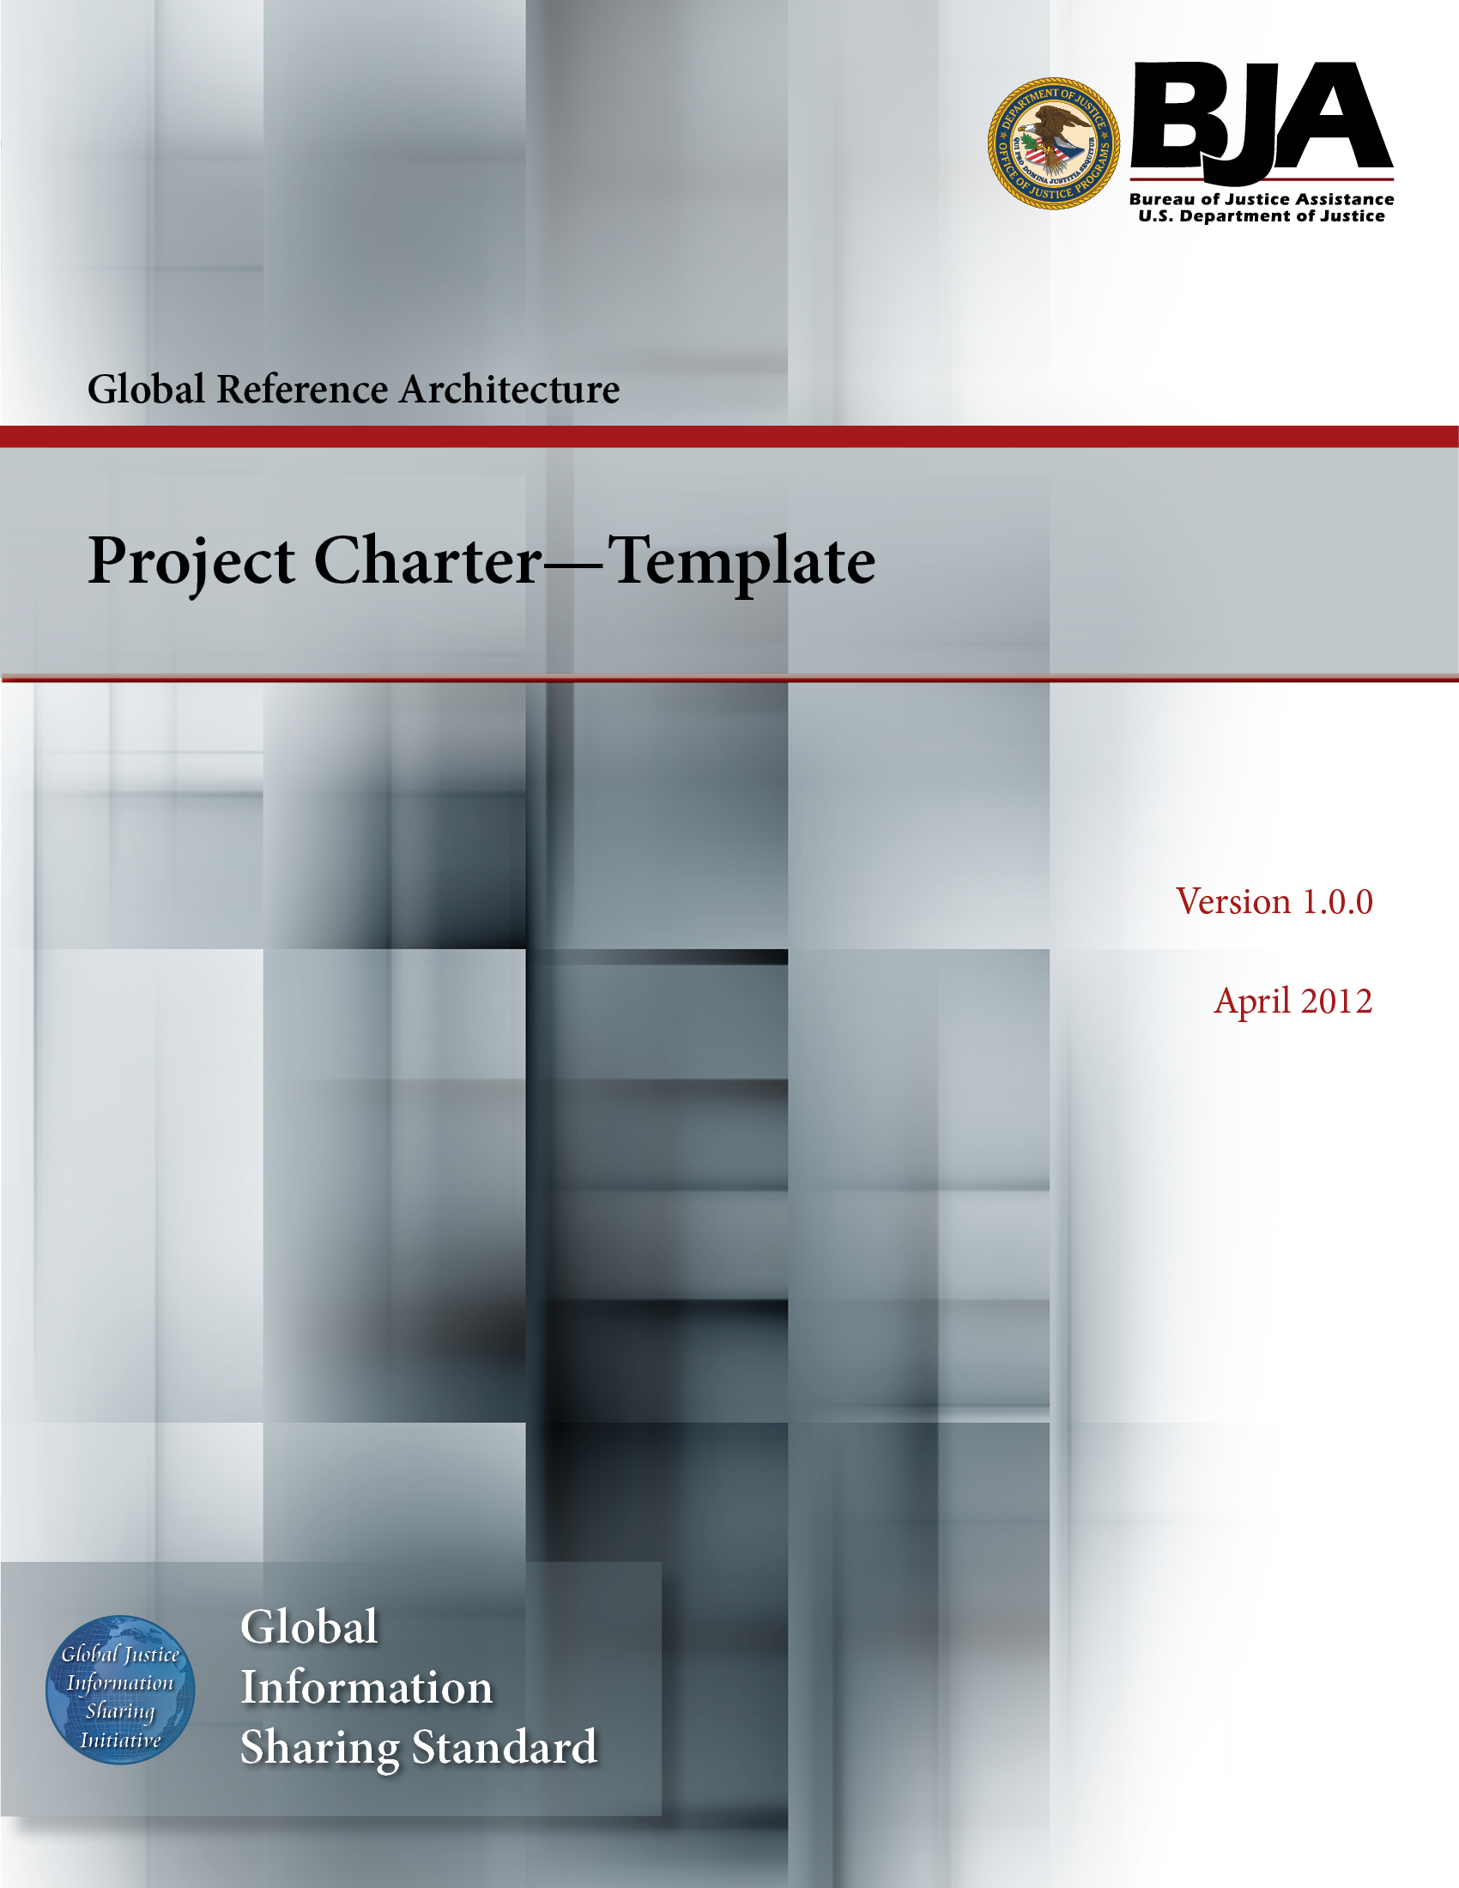
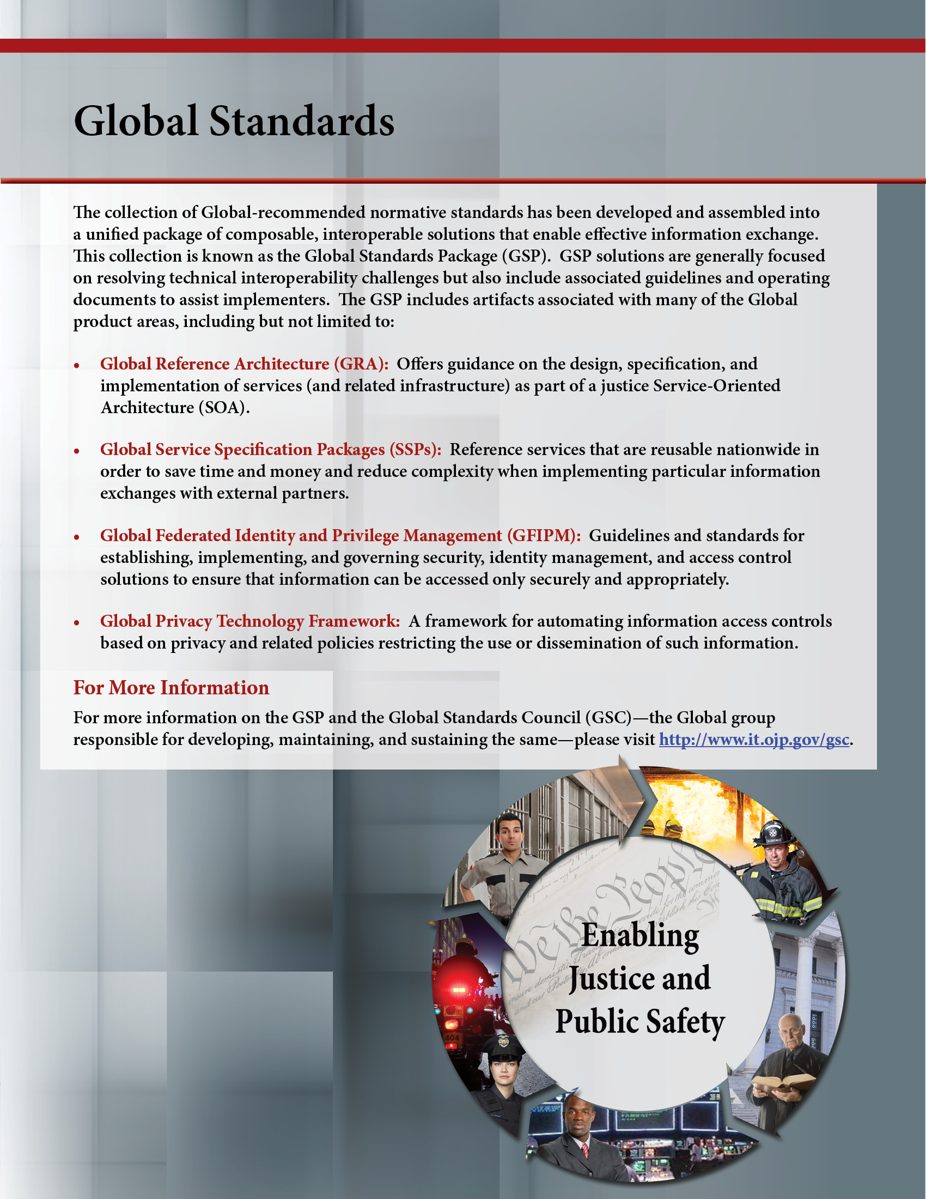

The Global Reference Architecture (GRA)

[Service Name] [Service Abbreviation] [Service Version]

Project Charter (Template)

Version 1.0.0

By [Name of Organization]

[Month Year]

Table of Contents

Document Conventions ii
1. Project Charter 1
2. Project Description 1
3. Project Roles and Responsibilities 1
4. Project Information 2
5. Approvals 2
Appendix A—References 3
Appendix B—Glossary 4
Appendix C—Document History 5

Document Conventions

[Note: The following template is provided for use with the Service Development Process. Text enclosed in square brackets and/or displayed in blue is included to provide guidance to the author and should be deleted before publishing the document.]

Project Charter

Project Name
Prepared By | Date

Project Description

Background Information (If this is a service project, include the service provider’s name.)
Project Objectives
Project Scope
Customers (If this is a service project, include the consuming organizations’ names.)

Project Roles and Responsibilities

Project Sponsor
Project Manager
Other Project Stakeholders
Core Team Members

Project Information

High-Level Deliverables
Assumptions
Constraints
Risks
Dependencies With Other Projects
Success Criteria

Approvals

Project Sponsor | Date
Project Manager (if assigned) | Date

Appendix A—References

[This section is used to list applicable references.]

[Reference name and description] | [Fully qualified link/path to the reference information]

Appendix B—Glossary

[This section is used to list glossary terms used in the document.]

[Glossary term or acronym] | [Glossary term or acronym description]

Appendix C—Document History

[This section is used to document the history of the service description document.]

Date | Version | Editor | Change
December 11, 2011 | 1.0.0 | James Dyche  Iveta Topalova | Final 1.0.0 revision
December 20, 2011 | 1.0.0 | David Gillespie | Initial edit of 1.0.0 revision
April 2012 | 1.0.0 | Global Standards Council (GSC) | Global Advisory Committee (GAC) approved



